A Well of Life

"Now whoever should drink out of the water which I will give to him, will NOT thirst forever, but the water which I will give to him will become a fountain of water in him, springing up unto everlasting life," John 4:14 (my translation). There were three kinds of wells in the Bible: a natural well, a man-made (dug) well, and an artesian well. Here is a picture of a beautiful woman filling up bottles from an artesian well located in Oklahoma. The word for "well" in John 4 is this kind of well. A well of life created by the Spirit of God flowing out from the believer--the best to be found, of the purest quality, and flowing freely for all to enjoy. O taste and see, that the Lord is good! (Psalm 34:8)

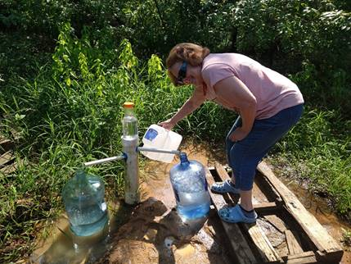

*Dr. Marvin J. Effa*